JBPM SetUp Documentation

Prepared by/Modified by |  | Role |  | Date of preparation/ Modification
Nagalakshmi Balasubramaniam |  |  |  | 26 Dec 2012
Reviewed by |  | Role |  | Date of Review
Approved by |  | Role |  | Date of Approval
Circulation List |  |  | Version Number of the Template | 1.0
VERSION NUMBER of the work product | V1.0

DOWNLOAD
All releases can be downloaded from SourceForge. Select the version you want to download and then select which artifact you want:
- bin: all the jBPM binaries (jars) and their dependencies
- src: the sources of the core components
- gwt-console: the jbpm console, a zip file containing both the server and client war
- docs: the documentation
- examples: some jBPM examples, can be imported into Eclipse
- installer: the jbpm-installer, downloads and installs a demo setup of jBPM
- installer-full: the jbpm-installer, downloads and installs a demo setup of jBPM, already contains a number of dependencies prepackages (so they don't need to be downloaded separately)

SOURCES FOR DOWNLOAD:
jBPM now uses git for its source code version control system. The sources of the jBPM project can be found here (including all releases starting from jBPM 5.0-CR1):
https://github.com/droolsjbpm/jbpm

Pre-requisites:
This script assumes you have Java JDK 1.5+ (set as JAVA_HOME), and Ant 1.7+ installed. If you don't, use the following links to download and install them:
Java: http://java.sun.com/javase/downloads/index.jsp
Ant: http://ant.apache.org/bindownload.cgi

First of all, you need to download the installer. There are two versions, a full installer (which already contains a lot of the dependencies that are necessary during the installation) and a minimal installer (which only contains the installer and will download all dependencies). In general, it is probably best to download the full installer: jBPM-{version}-installer-full.zip

Demo setup:
The easiest way to get started is to simply run the installation script to install the demo setup. Simply go into the install folder and run:
ant install.demo
This will:
- Download JBoss AS
- Download Eclipse
- Install Drools Guvnor into JBoss AS
- Install jBPM Designer into JBoss AS
- Install the jBPM console into JBoss AS
- Install the jBPM Eclipse plugin
- Install the Drools Eclipse plugin

For installing jBPM and Drools plugin into eclipse,place features and plugins in your jbpm-installer into eclipse features and plugins.The following are the required:
Features:
org.drools.eclipse.feature_5.5.0.Final
org.guvnor.tools.feature_5.5.0.Final
org.jbpm.eclipse.feature_5.5.0.Final
org.jbpm.eclipse.task.feature_5.5.0.Final
Plugins:
org.drools.eclipse_5.5.0.Final
org.guvnor.eclipse.webdav_5.5.0.Final
org.guvnor.tools_5.5.0.Final
org.jbpm.eclipse.task_5.5.0.Final
org.jbpm.eclipse_5.5.0.Final

Using the Eclipse tooling:
The following screencast gives an overview of how to run a simple demo process in Eclipse. It shows you:
- How to import an existing example project into your workspace, containing
  - a sample BPMN2 process for requesting a performance evaluation
  - a sample Java class to start the process
- How to start the process

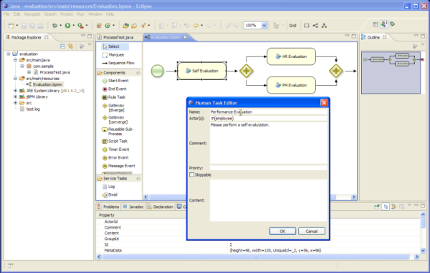

Do the following:
- Once Eclipse has opened, simply import (using "File -> Import ..." and then under the General category, select "Existing Projects into Workspace") the existing sample project (in the jbpm-installer/sample/evaluation directory). This should add the sample project, including a simple BPMN2 process and a Java file to start the process.
- You can open the BPMN2 process and the Java class by double-clicking it.
- We will now debug the process, so we can visualize its runtime state using the debug tooling. First put a breakpoint on line "logger.close()" of the ProcessTest class. To start debugging, right-click on ProcessTest.java in the com.sample package (under "src/main/java") and select "Debug As - Java Application", and switch to the debug perspective.
- Open up the various debug views: Under "Window - Show View -> Other ...", select the Process Instances View and Process Instance View (under Drools category) and the Human Task View (under jBPM Task) and click OK.
- The program will hit the breakpoint right after starting the process. In this case, it will simply start the process, which will result in the creation of a new user task for the user "krisv" in the human task service, after which the process will wait for its execution. Go to the Human Task View, fill in "krisv" under UserId and click Refresh. A new Performance Evaluation task should show up.
- To show the state of the process instance you just started graphically, click on the Process Instances View and then select the ksession variable in the Variables View. This will show all active process instances in the selected session. In this case, there is only one process instance. Double-click it to see the state of that process instance annotated on the process flow chart.
- Now go back to the Task View, select the Performance Evaluation task and first start and then complete the selected task. Now go back to the Process Instances view and double click the process instance again to see its new state.
You could also create a new project using the jBPM project wizard. This sample project contains a simple HelloWorld BPMN2 process and an associated Java file to start the process. Simply select "File - New - jBPM Project" (if you cannot see that (because you're not in the jBPM perspective) you can do "File - New ... - Project ..." and under the "jBPM" category, select "jBPM project" and click "Next"). Give the project a name and click "Finish". You should see a new project containing a "sample.bpmn" process and a "com.sample.ProcessMain" Java class and a "com.sample.ProcessTest" JUnit test class. You can open the BPMN2 process by double-clicking it. To execute the process, right-click on ProcessMain.java and select "Run As - Java Application". You should see a "Hello World" statement in the output console. To execute the test, right-click on ProcessTest.java and select "Run As - JUnit Test". You should also see a "Hello World" statement in the output console, and the JUnit test completion in the JUnit view.

Using the jBPM Console
Open up the process management console:
http://localhost:8080/jbpm-console
Log in, using krisv / krisv as username / password. The following screencast gives an overview of how to manage your process instances. It shows you:
- How to start a new process
- How to look up the current status of a running process instance
- How to look up your tasks
- How to complete a task
- How to generate reports to monitor your process execution

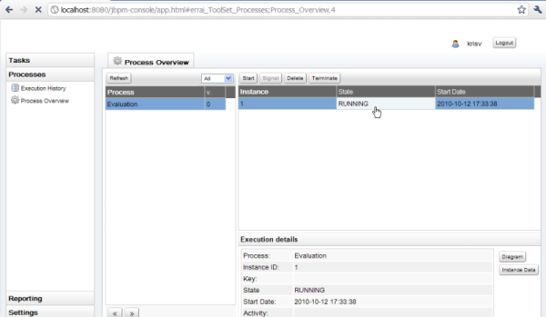

- To manage your process instances, click on the "Processes" tab at the left an select "Process Overview". After a slight delay (if you are using the application for the first time, due to session initalization etc.), the "Process" list should show all the known processes. The jbpm-console in the demo setup currently loads all the processes in the "src/main/resources" folder of the evaluation sample in "jbpm-installer/sample/evaluation". If you click the process, it will show you all current running instances. Since there are no running instances at this point, the "Instance" table will remain empty.
- You can start a new process instance by clicking on the "Start" button. After confirming that you want to start a new execution of this process, you will see a process form where you need to fill in the necessary information to start the process. In this case, you need to fill in your username "krisv" and a reason for the request, after which you can complete the form and close the window. A new instance should show up in the "Instance" table. If you click the process instance, you can check its details below and the diagram and instance data by clicking on the "Diagram" and "Instance Data" buttons respectively. The process instance that you just started is first requiring a self-evaluation of the user and is waiting until the user has completed this task.
- To see the tasks that have been assigned to you, choose the "Tasks" tab on the left and select "Personal Tasks" (you may need to click refresh to update your task view). The personal tasks table should show a "Performance Evaluation" task for you. You can complete this task by selecting it and clicking the "View" button. This will open the task form for performance evaluations. You can fill in the necessary data and then complete the form and close the window. After completing the task, you could check the "Process Overview" once more to check the progress of your process instance. You should be able to see that the process is now waiting for your HR manager and project manager to also perform an evaluation. You could log in as "john" / "john" and "mary" / "mary" to complete these tasks.
- After starting and/or completing a few process instances and human tasks, you can generate a report of what has happened so far. Under "Reporting", select "Report Templates". By default, the console has one report template, for generating a generic overview for all processes. Click the "Create Report" button to generate a realtime report of the current status. Notice that the initialization of the reports might take a moment, especially the first time you use the application.

- Using Guvnor repository and Designer
The Guvnor repository can be used as a process repository to store business processes. It also offers a web-based interface to manage your processes. This includes a web-based editor for viewing and editing processes.
Open up Drools Guvnor:
http://localhost:8080/drools-guvnor
Log in (if necessary), using any non-empty username / password (we disabled authentication for demo purposes). The following screencast gives an overview of how to manage your repository. It shows you:
- How to import an existing process (in this case the evaluation process) from eclipse into guvnor
- How to open up the evaluation process in the web editor
- How to build a package so it can be used for creating a session

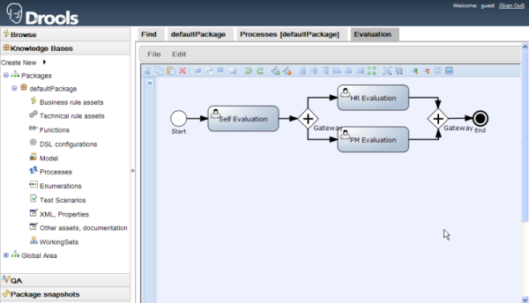

Once the demo setup has finished, you can start playing with the various components by starting the demo setup:

ant start.demo

This will:
Start the mySQL database
Start the JBoss AS
Start Eclipse
Start the Human Task Service

Using your own database with jBPM

Introduction:
In this quickstart, we are going to:
- modify the persistence settings for the process engine
- modify the persistence settings for the task server
- test the startup with our new settings!
You will need a local instance of a database, in this case MySQL in order to complete this quickstart
First though, let's look at the persistence setup that jBPM uses. In the demo, and in general, there are three types of persistent entities used by jBPM:
- entities used for saving the the actual session, process and work item information.
- entities used for logging and generating Business Activity Monitoring (BAM) information.
- entities used by the task service.
“persistent entities” in this context, are java classes that represent information in the database.

The demo uses two different persistent units:
- one for jBPM and the logging/BAM information-(spring-jbpm-context.xml)
- and one for the task service-(spring-app-context.xml)
The first persistence unit needs to use JTA, which is why we also need to define a separate datasource for that persistence unit as well.
The following 4 files define the persistence settings for the jbpm-installer demo:
- db/persistence.xml
- task-service/resources/META-INF/persistence.xml
- db/jBPM-ds.xml
  - If you're using the JBoss AS 5 server
- standalone.xml
  - If you're using the JBoss AS 7 server
Do the following:
db/persistence.xml:
This is the JPA persistence file that defines the persistence settings used by jBPM for both the process engine information and the logging/BAM information. The installer ant script moves this file to the expanded gwt console server war before the server is started.
In this file, you will have to change the name of the hibernate dialect used for your database.
The original line is:
<property name="hibernate.dialect" value="org.hibernate.dialect.H2Dialect"/>
In the case of a MySql database, you need to change it to:
<property name="hibernate.dialect" value="org.hibernate.dialect.MySQLDialect"/>

- task-service/resources/META-INF/persistence.xml:
The task service (that the installer starts) uses the JPA Persistence settings described in this file.
The original file contains the following lines:
<properties>
<property name="hibernate.dialect" value="org.hibernate.dialect.H2Dialect"/>
<property name="hibernate.connection.driver_class" value="org.h2.Driver"/>
<property name="hibernate.connection.url" value="jdbc:h2:tcp://localhost/runtime/task" />
<property name="hibernate.connection.username" value="username"/>
<property name="hibernate.connection.password" value="password"/>
Please change these lines so that they look like this:
<properties>
<property name="hibernate.dialect" value="org.hibernate.dialect.MySQLDialect"/>
<property name="hibernate.connection.driver_class" value="com.mysql.jdbc.Driver"/>
<property name="hibernate.connection.url" value="jdbc:mysql://localhost:3306/jbpmworkflow" />
<property name="hibernate.connection.username" value="username"/>
<property name="hibernate.connection.password" value="password"/>

- db/jBPM-ds.xml:
This step is only neccessary if you're using JBoss AS 5.
This file is the configuration for the (JTA) datasource used by the jBoss AS 5 instance for the process engine persistence. The installer ant script moves this file to the jboss server deploy directory.

The original file contains the following lines:
<datasources>
<local-tx-datasource>
<jndi-name>jboss/datasources/jbpmDS</jndi-name>
<connection-url>jdbc:h2:tcp://localhost/runtime/jbpm-demo</connection-url>
<driver-class>org.h2.jdbcx.JdbcDataSource</driver-class>
<user-name>sa</user-name>
<password></password>
</local-tx-datasource>
</datasources>
Please change these to the following:
<datasources>
<local-tx-datasource>
<jndi-name>jboss/datasources/jbpmDS</jndi-name>
<connection-url>jdbc:mysql://localhost:3306/jbpm5</connection-url>
<driver-class>com.mysql.jdbc.jdbc2.optional.MysqlXADataSource</driver-class>
<user-name>username</user-name>
<password>password</password>
</local-tx-datasource>
</datasources>

- standalone.xml:
This step is only neccessary if you're using AS 7.
This file is the configuration for the standalone JBoss AS 7 server. When the installer starts the demo (using jBoss AS 7), it moves this file to the standalone/configuration directory in the jboss server directory
We need to change the datasource configuration in standalone.xml so that the (JTA) datasource for the jBPM process engine and logging/BAM points to our MySQL database
The original file contains the following lines:
<subsystem xmlns="urn:jboss:domain:datasources:1.0">
<datasources>
<datasource jndi-name="java:jboss/datasources/jbpmDS" enabled="true" use-java-context="true" pool-name="H2DS">
<connection-url>jdbc:h2:tcp://localhost/runtime/jbpm-demo</connection-url>
<driver>h2</driver>
<pool></pool>
<security>
<user-name>sa</user-name>
<password></password>
</security>
</datasource>
<drivers>
<driver name="h2" module="com.h2database.h2">
<xa-datasource-class>org.h2.jdbcx.JdbcDataSource</xa-datasource-class>
</driver>
</drivers>
</datasources>
</subsystem>
Change the lines to the following:
<subsystem xmlns="urn:jboss:domain:datasources:1.0">
<datasources>
<datasource jndi-name="java:jboss/datasources/jbpmDS" pool-name="H2DS" enabled="true" use-java-context="true">
<connection-url>jdbc:mysql://localhost:3306/jbpm5</connection-url>
<driver>mysql</driver>
<pool></pool>
<security>
<user-name>username</user-name>
<password>password</password>
</security>
</datasource>
<drivers>
<driver name="mysql" module="com.mysql">
<xa-datasource-class>com.mysql.jdbc.jdbc2.optional.MysqlXADataSource</xa-datasource-class>
</driver>
</drivers>
</datasources>

In order to setup the mysql database for the JBPM we have to configure the database information in many files. By default jbpm comes with the H2 database which is not stable to use production environment. This set up process is applicable for all other databases with their respective information.
Steps:
- There is db folder inside the jbpm bundle. Place the mysqlconnector.jar inside db/driver folder.
- Change the database configuration details such as username, password, connection url, driver, dialect information for the following files under db folder.
  - jBPM-ds.xml
  - persistence.xml

- For the task related tables change the above mentioned details inside the taskservice folder for the following files.
  - taskservice/resources/META-INF/persistence.xml
- Next we have to configure the datasource information inside the Jboss standalone.xml.
- Before that inside the Jboss modules/com folder create the mysql/main folder and copy the mysqlconnector.jar and create the module.xml in it.
- Type command for starting jboss as ant start.jboss
- Type command for starting human task as ant start.human.task
- In Sql Command prompt,for accessing database with our username:

GRANT ALL PRIVILEGES ON *.* TO 'root'@'localhost' IDENTIFIED BY 'root' WITH GRANT OPTION

- Once these changes are done start the jboss then start the human task service. As soon as the human task service is started the following tables will be created in the database.
  - attachment
  - booleanexpression
  - content
  - deadline
  - delegation_delegates
  - email_header
  - escalation
  - eventtypes
  - i18ntext
  - notification
  - notification_bas
  - notification_email_header
  - notification_recipients
  - organizationalentity
  - peopleassignments_bas
  - peopleassignments_exclowners
  - peopleassignments_potowners
  - peopleassignments_recipients
  - peopleassignments_stakeholders
  - reassignment
  - reassignment_potentialowners
  - subtasksstrategy
  - task
  - task_comment

- Once we log in to the jbpm console then the following tables will be created which holds process details.
  - processinstanceinfo
  - sessioninfo
  - workiteminfo

- Next if we create the new process instance in the jbpm console then the following tables gets created.
  - processinstancelog
  - nodeinstancelog

Notes:
- AuditLog.hbm.xml which contains audit table information which has been seen in jbpm-bam-5.2.0.Final.jar
- ProcessInstanceInfo,SessionInfo,WorkItemInfo table details are seen in persistence.xml.
- The hibernate mappings for task related tables are available in Taskorm.xml which we can see in gwt-console-server.war file WEB-INF/classes/META-INF and jbpm-human-task-5.2.0.Final.jar file inside the runtime directory
- JBPMorm.xml file coontains query to fetch data from the ProcessInfo table.

